**Government College Of Engineering, Amravati**

(An Autonomous Institute of Government of Maharashtra)

Department of Information Technology

(2018-2019)

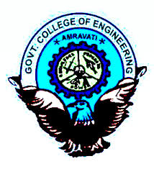

**CERTIFICATE**

This is to certify that the project entitled, “TechnoMate” which is being submitted here with for the reward of B.Tech is the result of the work being completed by following students under my supervision and guidance within the four walls of the institute.

Has been submitted by:

Divya D. Dubey(17107001)

Komal P.Manoja(17107007)

Adarsh H. Basantwani(17107008)

Prof.A.D.Wankhade Examiner Prof. A.W. Bhade

(Guide) (Head of the Department)